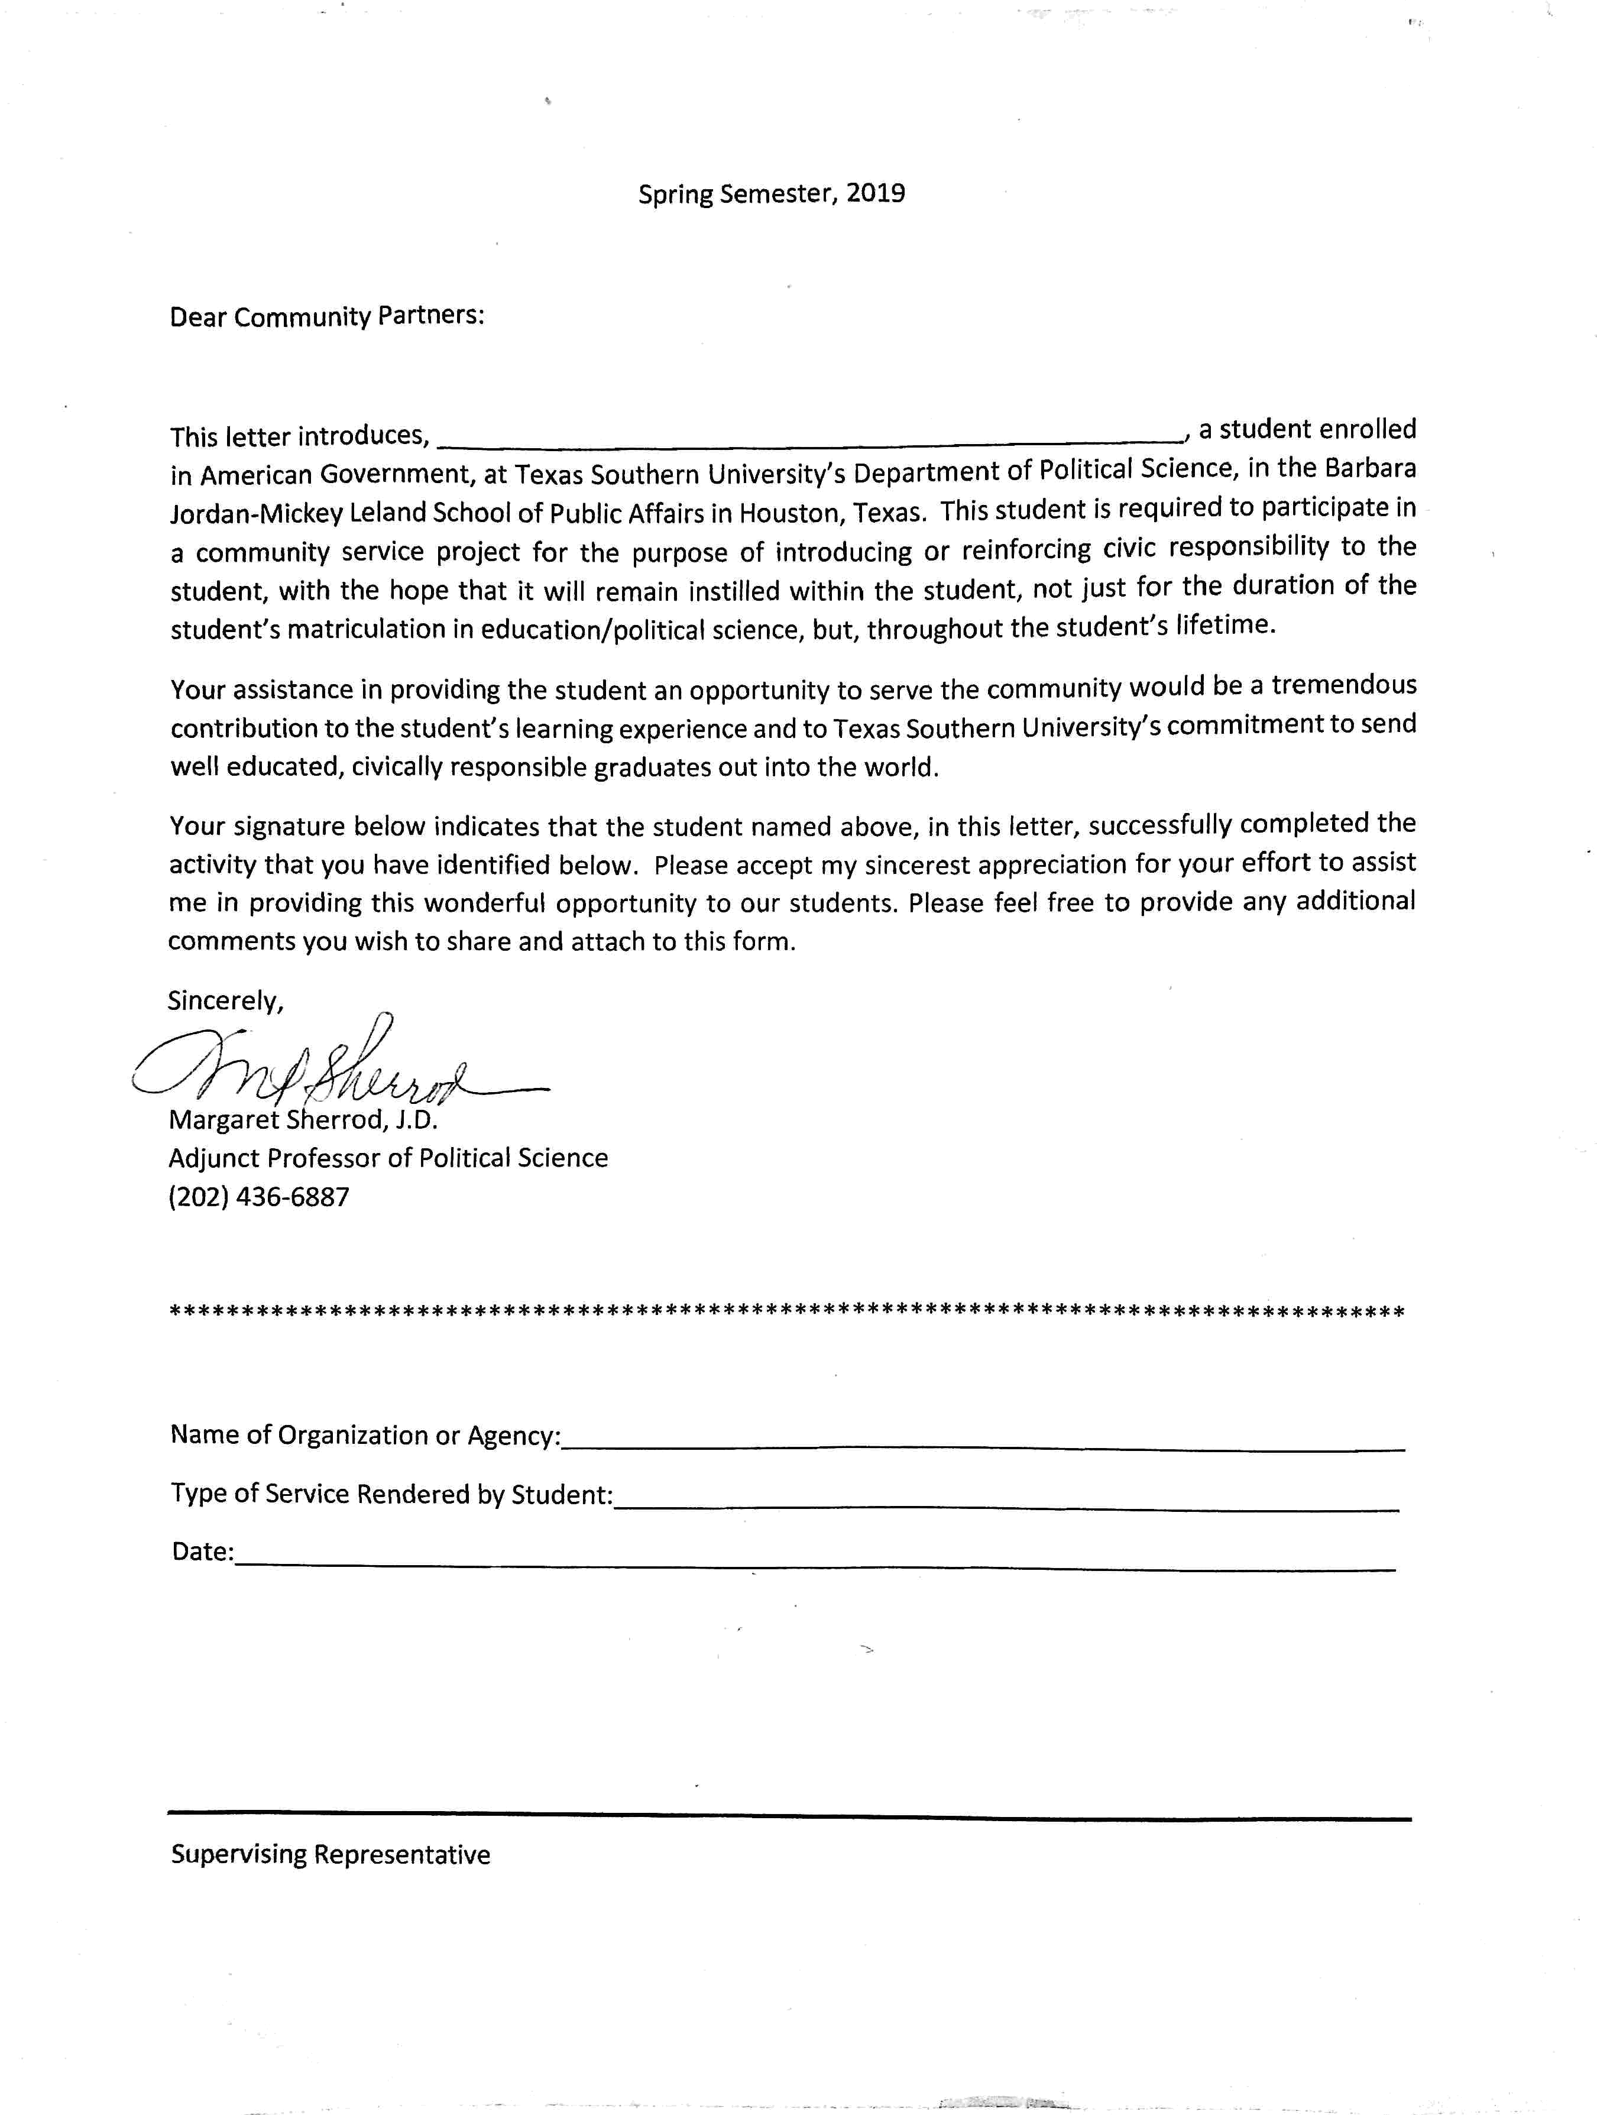

May 15th, 2019

kitksumnstapct

Community services
Institutional affiliation
Name of lecturer
Name of student
Date of submission

Introduction
Being a student at Texas southern university under the department of political science, I participated in a community service project at Northwest Assistance Ministries (NAM.) NAM is a nonprofit organization which is community-based and provides a multiple of programs on social agencies. The organization provides basic needs to humans through neighbor help neighbor, that is, through voluntary services, and donations. The organization offers services like food, shelter education, safety, health and financial education to the society. NAM services cover 22 zip codes of Northwestern of Houston, Texas. The mission of NAM is based on neighbors to help neighbors in meeting basic human needs. The vision of the organization is based on the mission by promoting its core values. Nam thus advocates for community partners, area congregation, donors and volunteers in meeting community needs. Through the pooling of resources, basic needs are met and help people to regain personal sufficiency. Through this, a more stable and safer community is created. The core values of NAM are: the foster spirit of charity and respect, strive for excellence, commitment to the mission of meeting basic human needs, strengthen spiritual, funding, and volunteer connections (Rodriguez 1987.)
NAM provides several services to the community. Some of these services are; training and learning center, where adults are helped to gains skills towards a career that enables them to be financially stable. This was my main target of assistance. Though they collaborate with other organization like Harris County under the department of education and lone star college, adults learn English, take GED exams, participate in vocational training, and take adult basic education. Under the adult basic education, we were able to teach the adults on their role in both the state governments and the federal government. Both the youths and the adults in any society have the obligation of participating in public programs that help in development. Conducting these programs for the first two weekend of March, I participated in training adults to adopt a career that some of them wished to pursue in high education. This was on political obligations of every individual in a state or the federal government. Highlighting some of the topic carried out during the training, the adults acquired knowledge on voting rights. Another service that is provided by NAM is Meals on Wheel. This service offers a well-balanced diet to individuals who have disabilities or illness. This is a door to door service. This was another significant aspect that I participated in. Taking food to the disabled was quite enjoyable as I was able to interact with them and give words encouragement to them. Some people don't value people living with disabilities and thus neglect them. Visiting such people support them. Other aspects that I took part are; family violence center, where victims of family violence and sexual harassment are assisted, disaster relief assistance where more than 14,500 individuals are assisted with food, rent, mortgage, hygiene products, and home repairs.
The services that I participated in are quite crucial. Through training and learning, adults acquire necessary skills that enhance their career path. From the training, adults are groomed towards a career that will lead them to financial stability. Also, they are able to learn the basics of English as their second language. The community thus eliminates illiteracy level and even poverty. The community also understands its responsibilities towards the development of the country. Through meals on the wheel, the disabled recognized and thus discourage discrimination. These services were quite beneficial to me as a student and any other student who wish to pursue such an activity in a community. Through the training that is done by NAM, the necessary skills of instruction and administration are acquired. Also, a student learns the problems that face adults, and thus he or she can plan his future with respect to the learned issues. Through interaction with disabled, the student acquires a more caring responsibility and therefore can treat each in the society equally with discrimination or favor.

References
Rodriguez, N. P. (1987). Undocumented central Americans in Houston: diverse populations. International Migration Review, 21(1), 4-26.

